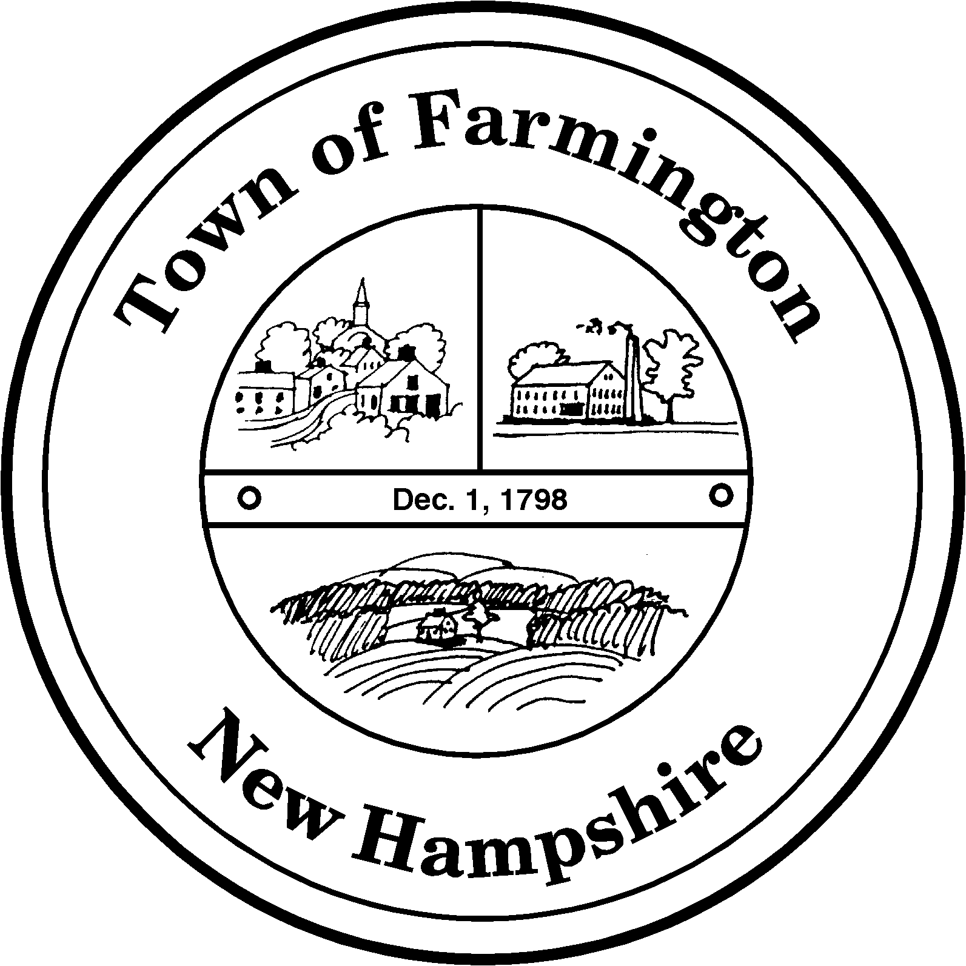
Town of Farmington
Planning and Community Development
356 Main Street
Farmington, NH 03835
Phone: (603) 755-2774
A Bicentennial Community
1798 - 1998

PLANNING BOARD MEETING

Tuesday – May 17, 2016

356 Main Street - Farmington, NH

AGENDA - 6:00 pm

BUSINESS BEFORE THE BOARD:

- Pledge of Allegiance
- Review and approve Meeting Minutes of
- Any other business to come before the Board
  - Chestnut Hill Subdivision – Site Visit
  - Review of Excavation Permit compliance

PUBLIC HEARING - 6:30 pm

CONTINUED CASES:

Application for Major Site Plan Review by Brew Brothers, LLC through Jones & Beach Engineers, Inc., as Agent (Tax Map R-20, Lot 23-1): The applicant proposes to construct an Aroma Joe’s coffee shop and self storage facility. The parcel is located on NH Route 11 and is located in the Commercial Industrial Business (CIBO) District. Parcel is owned by Richard Sevigney, III.

NEW CASES:
Application for Major Site Plan Approval By: Guy and Desiree Hafford Family Realty Trust through Scott Lawler, PE, Norway Plains Associates, Inc., Agent (Tax Map U8 Lot 32-1): To approve the construction of a 2,112 square foot building addition, the renovation of the existing Residential Care Facility (“Hattie’s Place”) to increase the number of beds from twelve (12) to fifteen (15), and the expansion of the existing parking lot and septic system. The parcel is located at 256 Main Street in the Suburban Residential (SR) District.

